CENTRE FOR DISTANCE AND ONLINE EDUCATION
GENERAL GUIDELINES
FOR
REMOTE PROCTORED PRACTICAL TERM END EXAMINATIONS –July-August-September 2025

Practical Term-End Examinations for BCA & MCA– Sem 1, 2, 3, 4, 5 & 6 are scheduled as mentioned in the Table 1. Learners are required to book the slot through the Online Examination Booking System (OEBS) for the course as per the available slots only.

Practical TEE Dates

Semester | Examination Dates | OEBS Slot Booking Window | Mock Exam Dates
1, 4, 6 | 26th July 2025 to 14th August 2025 | 17th July 2025 to 22nd July 2025 | 20th July to 25th July 2025
2, 3, 5 | 20th August 2025 to 7th Sept. 2025 | 17th July 2025 to 22nd July 2025 | 18th August to19th August 2025
Table 1: Practical TEE schedule
Important Instructions:

- The Duration of the Practical Examination is 2 Hours, and the Maximum Marks are 30.
- Learners can log in within 30 minutes of the start time of the practical exam.
- Each learner is required to book the slot through OEBS to appear in Practical TEE.
- The Practical Examination is divided into two parts – Section A (20 marks) & Section B (10 marks).
- Both Section A & Section B activities are required to be carried out in 2 hours.
- Section A consists of 2 programming questions (project), each carrying equal marks.
- Section B requires recording of your viva-voce video in LMS, which must be taken only after Section A is completed.
- Both sections A & B are compulsory

Hardware & Software Requirements

- Desktop/Laptop (Windows) with webcam & microphone in good working condition.
- Active Internet connection with good speed.
- Google Chrome installed on the Desktop/Laptop.

Check your computer compatibility, including webcam, microphone, browser and network for appearing in the examinations using the link - https://systemcheck.talent-next.com/

The Minimum Configuration required for desktop/ laptop which will be used for appearing examinations are given below:

Hardware/ Software | Minimum requirements
Processor | Intel Core i3 or above with 2.2 GHz or more clock speed
RAM | 2 GB or above
Operating system | Windows 7 and above (up-to-date service pack, device  drivers, security patches, this exam will run only on the windows operating system)
Web browser | The latest version of Chrome and .Net Version 4.5.2 or above
Web camera | 640x480, 15 fps (Internal or External and connected to  computer, Camera must run natively in OS and not with help of other software)
Microphone | Any
Screen resolution | 1024 x 768 and above
Network response | Not more than 1000 ms
Network ports and protocols | 443/tcp, 3478/tcp, 3478/udp
Internet | 2 MBPS or more - Dedicated & Continuous Connectivity (Wired or Wireless Network). The candidate exam system will be  directly connected to the cloud server
Antivirus | Should be disabled

DO NOT start the examinations if your desktop/laptop does not meet the above requirements.

How to take Remote proctored Examinations?
Section A:
Follow the steps mentioned below to appear for the examination:
- Log in to the student portal https://student.onlinemanipal.com with your university email and password.
- Choose Learning Portal to log in to LMS.
- Choose the course tile for which you want to appear for practical Exercises.
- Choose Virtual Programming Lab from the modules.
- Click the link for launching Practical.
- Click the Start button to start the Term End Practical Examination submission, it will redirect you to your first assessment question.
- Click on the Start Coding button and it will redirect to the Remote Proctoring (RP) page. Check the check box and click on “Continue”.
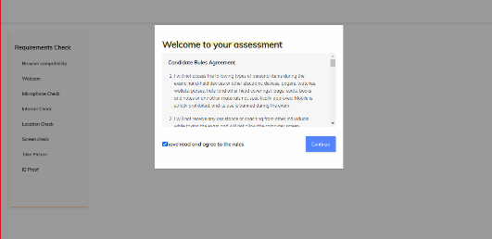

- Requirements will be checked by the system, so the user should have a good Internet connection and need to allow access to Webcam, Microphone, and Location. After the location check, the below screen will be displayed, click on the “Start Capture” button, so as to do the screen check.

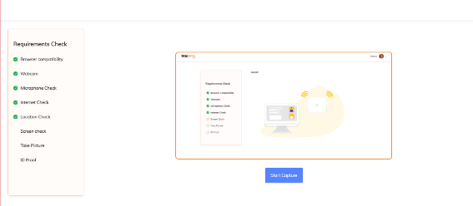

- Clicking on Start Capture, the below screen will be displayed so as to select the screen to share. Click on the Share button.
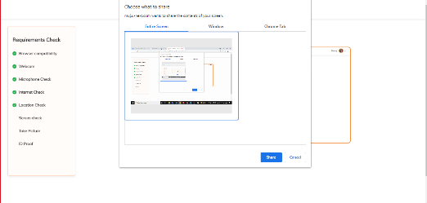

- Click on Next.
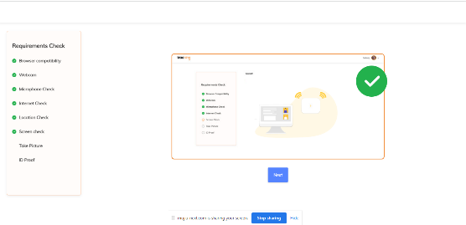
- After clicking on “Next”, system will take your picture. Click on Take Picture.
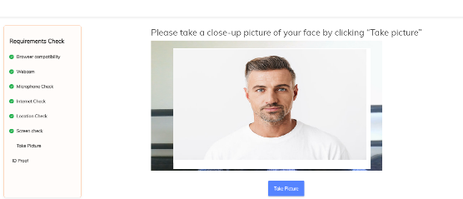
Please ensure that your full & uncovered face is visible, the room is well illuminated, the background is clear

- Click on Next.
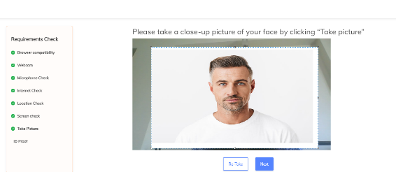

- Click on Take a picture again with ID Proof.
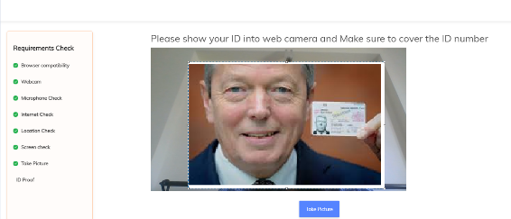
Please ensure that your full ID card is visible, the room is well illuminated, use valid government ID proof (same as you did for your theory exams)
- Again, click on Next and it will redirect you to your first assessment question.
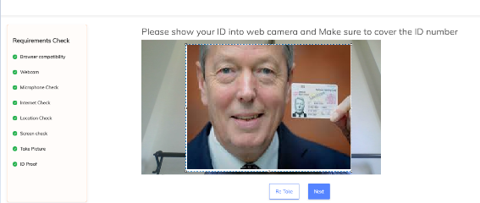

- Wait till the below pop up comes and then click on Yes, Continue button.

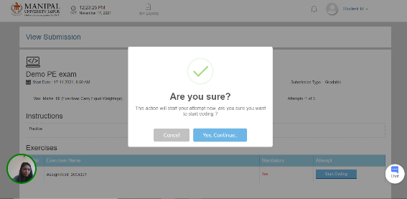

- After clicking on Yes, Continue, it will take you to the Programming Environment page.

Steps for Submission of TEE exercise:
Section A
- Read the question/instructions and start working on your first assessment question. Then compile & execute it and then click on Submit Project Button.
- Then click on the Next Project Option, it will redirect you to the second assessment question. Repeat step 1.
- Finally click on Submit Exercise Button after completion of the last project.

Section B:
- Log in to the student portal https://student.onlinemanipal.com with your university email and password.
- Choose Learning Portal to log in to LMS.
- Choose the appropriate course tile for which you want to appear for viva voce questions.
- Go to the Test & Assignment menu click on the Assignments sub-menu and access Term End Practical Viva-Voce.
- Use Record Video to submit your answers.

Failing to follow the above steps before starting the examination will lead to non-submission of examinations, and you will be marked ABSENT.

Unfair Means (Malpractice)

- Examination will be proctored by the University Invigilators in addition to digital proctoring
- You shall be monitored for the entire duration of the examination and video; audio and examination screens are recorded while you are appearing for examinations.
- Ensure that the webcam always focuses on you.
- Your examination will be canceled and will be booked for unfair means.
- (Malpractice) under the below circumstances
    - If you move out of your place once the examination starts.
    - At any point if it is found that the webcam or microphone is not connected or is not functional
    - Using mobile, google search or any other app support during the examination.

Troubleshooting during the Examination
- You shall receive technical helpdesk contact details to which you may call to get any kind of technical support related to the computer system and software requirement.

Technical Contact Details: 9513850031 (For Remote Proctor)
Helpdesk Contact Details: 7996600444

